1. **有两块很重要的数据模块。**

A.**DTVPROGRAMID_M**

B. **DTV_CHANNEL_INFO**

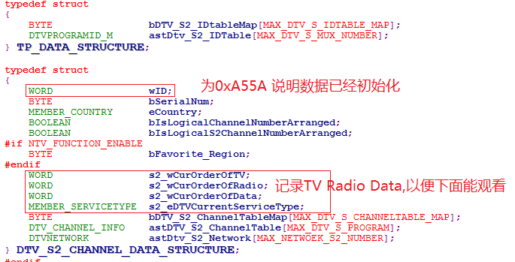

查看软件中的msAPI_CM_InitDTVDataManager函数中的CreatDTVProgramIndexTableAndProgramIDTable我们就知道，通过上面数据会创建下面重要数据TABLE.

1. **从数据表中初始化下面Table。**

A. 通过下面函数创建（**m_acDVB_S_ProgramTableMap**）。



B.通过下面函数创建（**_m_astDVB_S_ProgramIndexTable**）。



C.通过下面函数创建（**m_acDVB_S_IdtableMap _astDVB_S_ProgramIDTable**）。



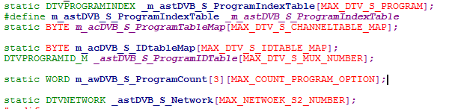

1. **我们先来看下添加节目函数msAPI_SI_AddProgram()。**



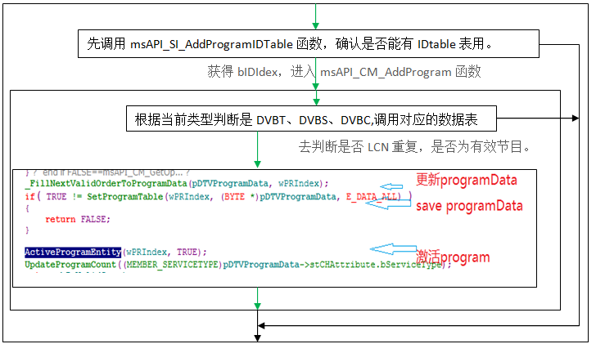

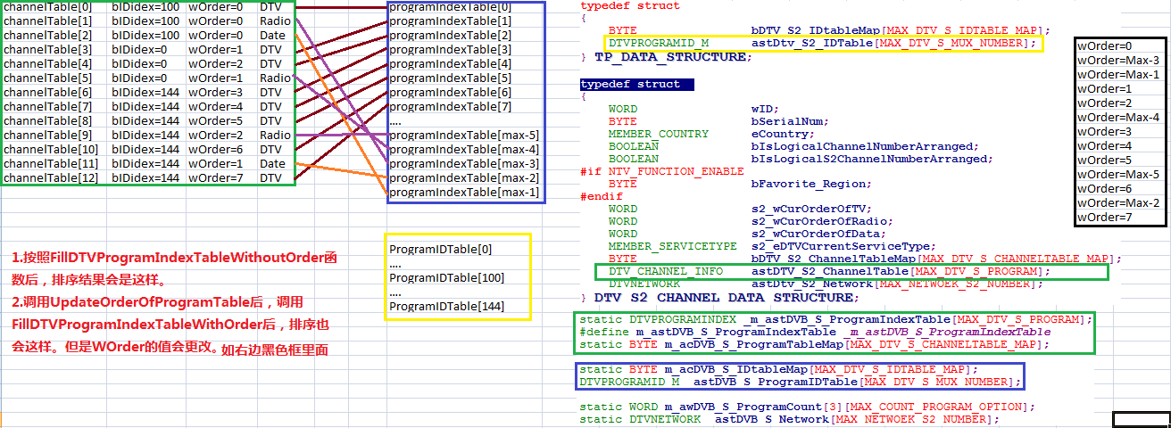

1. **我们再一起看下删除节目函数**msAPI_CM_DeleteProgram()**。**



注意：如果删除当前节目，如何处理。

1. **MOVE节目时，那些数据需要处理。**

主要是channelTable数据交换，还有就是channelTable里面的WOrder 内容交换。

1. **再看初始化节目函数msAPI_CM_InitDTVDataManager()。**



注意：初始化节目时，函数FillDTVProgramIndexTableWithOrder与FillDTVProgramIndexTableWithoutOrder的区别。

1. **下面我们就来看节目排序。**

可以把DTV_CHANNEL_INFO中的wOrder按照FillDTVProgramIndexTableWithoutOrder函数排列赋值。

FillDTVProgramIndexTableWithOrder FillDTVProgramIndexTableWithoutOrder

如果DTV_CHANNEL_INFO有下面这些数据，channelist分别调用上面函数后，显示会如何。



1. 看下下面函数结果会如何。我们分析下DTV CountProgram函数.为什么会出现这样的情况。可以通过下面的debug1(void)函数打印。

WORD CountProgram(MEMBER_SERVICETYPE bServiceType, COUNT_PROGRAM_OPTION eCountOption)

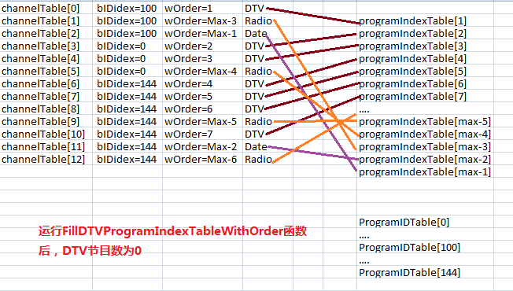

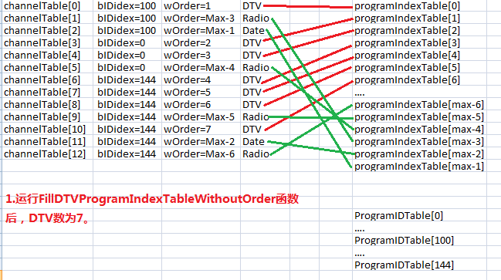

B．下面我们再来看下显示的台号，通过下面的函数，我们知道其实就是显示DTV的LCN号。可以通过下面的void debug2(void)函数打印

msAPI_CM_GetLogicalChannelNumber((MEMBER_SERVICETYPE)SERVICE_TYPE_RADIO,g_wProgramPosition)

C.我们再来看下节目交换功能。可以通过下面的void debug3(void)函数打印

D．打印节目函数.可以通过下面的void debug4(void)函数打印

void debug1(void)

{

DTVPROGRAMINDEX *pProgramIndexTable=m_astDVB_T_ProgramIndexTable;

#if DVB_T_C_DIFF_DB

if (msApi_GetDVBType() ==EN_DVB_C_TYPE )

{

pProgramIndexTable=m_astDVB_C_ProgramIndexTable;

}

#endif

#if ENABLE_S2

if (msApi_GetDVBType() ==EN_DVB_S2_TYPE )

{

pProgramIndexTable=m_astDVB_S_ProgramIndexTable;

}

#endif

FillProgramIndexWithDefault(&pProgramIndexTable[0]);

printf("ProgramCount(%d)\n",GetProgramCount(E_SERVICETYPE_DTV,INCLUDE_ALL));

UpdateProgramCount(E_SERVICETYPE_DTV);

printf("ProgramCount(%d)\n",GetProgramCount(E_SERVICETYPE_DTV,INCLUDE_ALL));

}

void debug2(void)

{

WORD wPosition;

WORD wOrder;

WORD wSimu_LCN=0;

WORD wMaxDtvProgram= MAX_DTVPROGRAM;

DTVPROGRAMINDEX *pProgramIndexTable=m_astDVB_T_ProgramIndexTable;

#if DVB_T_C_DIFF_DB

if (msApi_GetDVBType() ==EN_DVB_C_TYPE )

{

wMaxDtvProgram= MAX_DTV_C_PROGRAM;

pProgramIndexTable=m_astDVB_C_ProgramIndexTable;

}

#endif

#if ENABLE_S2

if (msApi_GetDVBType() ==EN_DVB_S2_TYPE )

{

wMaxDtvProgram= MAX_DTV_S_PROGRAM;

pProgramIndexTable=m_astDVB_S_ProgramIndexTable;

}

#endif

for(wPosition=0; wPosition < wMaxDtvProgram; wPosition++)

{

wOrder = ConvertPositionToOrder(E_SERVICETYPE_DTV, wPosition);

if( E_SERVICETYPE_DTV == pProgramIndexTable[wOrder].bServiceType )

{

wSimu_LCN=pProgramIndexTable[wOrder].wSimu_LCN*2;

pProgramIndexTable[wOrder].wSimu_LCN=wSimu_LCN;

pProgramIndexTable[wOrder].wLCN=wSimu_LCN;

if(IsProgramEntityActive(pProgramIndexTable[wOrder].wPRIndex))

{

SetProgramTable(pProgramIndexTable[wOrder].wPRIndex, (BYTE *)&wSimu_LCN, E_DATA_LCN);

SetProgramTable(pProgramIndexTable[wOrder].wPRIndex, (BYTE *)&wSimu_LCN, E_DATA_SIMU_LCN);

}

}

else

{

break;

}

}

}

void debug3(void)

{

DTVPROGRAMINDEX *pProgramIndexTable=m_astDVB_T_ProgramIndexTable;

#if DVB_T_C_DIFF_DB

if (msApi_GetDVBType() ==EN_DVB_C_TYPE )

{

pProgramIndexTable=m_astDVB_C_ProgramIndexTable;

}

#endif

#if ENABLE_S2

if (msApi_GetDVBType() ==EN_DVB_S2_TYPE )

{

pProgramIndexTable=m_astDVB_S_ProgramIndexTable;

}

#endif

DTVPROGRAMINDEX ProgramIndexTableBack;

memcpy(&ProgramIndexTableBack,&pProgramIndexTable[2],sizeof(DTVPROGRAMINDEX));

memcpy(&pProgramIndexTable[2],&pProgramIndexTable[3],sizeof(DTVPROGRAMINDEX));

memcpy(&pProgramIndexTable[3],&ProgramIndexTableBack,sizeof(DTVPROGRAMINDEX));

}

void debug4(void)

{

BYTE bChannelName[MAX_SERVICE_NAME];

WORD wOrder,wOrder2;

WORD wSimu_LCN;

WORD wMaxDtvProgram= MAX_DTVPROGRAM;

CHANNEL_ATTRIBUTE stCHAttribute;

DTVPROGRAMINDEX *pProgramIndexTable=m_astDVB_T_ProgramIndexTable;

#if DVB_T_C_DIFF_DB

if (msApi_GetDVBType() ==EN_DVB_C_TYPE )

{

wMaxDtvProgram= MAX_DTV_C_PROGRAM;

pProgramIndexTable=m_astDVB_C_ProgramIndexTable;

}

#endif

#if ENABLE_S2

if (msApi_GetDVBType() ==EN_DVB_S2_TYPE )

{

wMaxDtvProgram= MAX_DTV_S_PROGRAM;

pProgramIndexTable=m_astDVB_S_ProgramIndexTable;

}

#endif

printf("ProgramIndexTable\n");

for(wOrder=0; wOrder < wMaxDtvProgram; wOrder++)

{

if(IsProgramEntityActive(pProgramIndexTable[wOrder].wPRIndex))

{

memset(bChannelName, 0x00, MAX_SERVICE_NAME);

GetProgramTable(pProgramIndexTable[wOrder].wPRIndex, (BYTE *)bChannelName, E_DATA_SERVICE_NAME);

GetProgramTable(pProgramIndexTable[wOrder].wPRIndex, (BYTE *)&wOrder2, E_DATA_ORDER);

GetProgramTable(pProgramIndexTable[wOrder].wPRIndex, (BYTE *)&wSimu_LCN, E_DATA_SIMU_LCN);

GetProgramTable(pProgramIndexTable[wOrder].wPRIndex, (BYTE *)&stCHAttribute, E_DATA_MISC);

if(E_SERVICETYPE_DTV==stCHAttribute.bServiceType)

{

printf("DTV wOrder =%4d.%4d,wPRIndex=%4d,Lcn=%4d.%4d [%s]\n",wOrder,wOrder2,pProgramIndexTable[wOrder].wPRIndex,pProgramIndexTable[wOrder].wSimu_LCN,wSimu_LCN,bChannelName);

}

if(E_SERVICETYPE_RADIO==stCHAttribute.bServiceType)

{

printf("RADIO wOrder =%4d.%4d,wPRIndex=%4d,Lcn=%4d.%4d [%s]\n",wOrder,wOrder2,pProgramIndexTable[wOrder].wPRIndex,pProgramIndexTable[wOrder].wSimu_LCN,wSimu_LCN,bChannelName);

}

if(E_SERVICETYPE_DATA==stCHAttribute.bServiceType)

{

printf("DATA wOrder =%4d.%4d,wPRIndex=%4d,Lcn=%4d.%4d [%s]\n",wOrder,wOrder2,pProgramIndexTable[wOrder].wPRIndex,pProgramIndexTable[wOrder].wSimu_LCN,wSimu_LCN,bChannelName);

}

}

}

}